## **Tesla Social Media Analytics for Strategic Branding**

## **Task 1: Data Preprocessing & Cleaning**

### 1.1 Remove duplicate Tesla posts.

Load the data sets into power query editor and remove the duplicates. There are no duplicates

found in the given data sets.

### Standardize date & platform names.

Make sure there are no spaces in the text of platform names and all should be in proper case.

Check whether date column is in calendar format.

### 1.3 Format numeric columns (Likes, Reach, Impressions, Ad Spend).

Select the columns and use the number group on home tab ribbon.

### 1.4 Split hashtags (e.g., #Cybertruck, #EVRevolution, #TeslaEnergy) into individual tags.

Load the data into power query editor.

Select the column that has to be split. Divide the column based on delimiter “comma” because after every comma we have new hashtag name. Now we have three different columns related to hashtags. Select these 3 columns and unpivot the columns to create one single column in which we can able to see all the hashtags under one column hashtags.

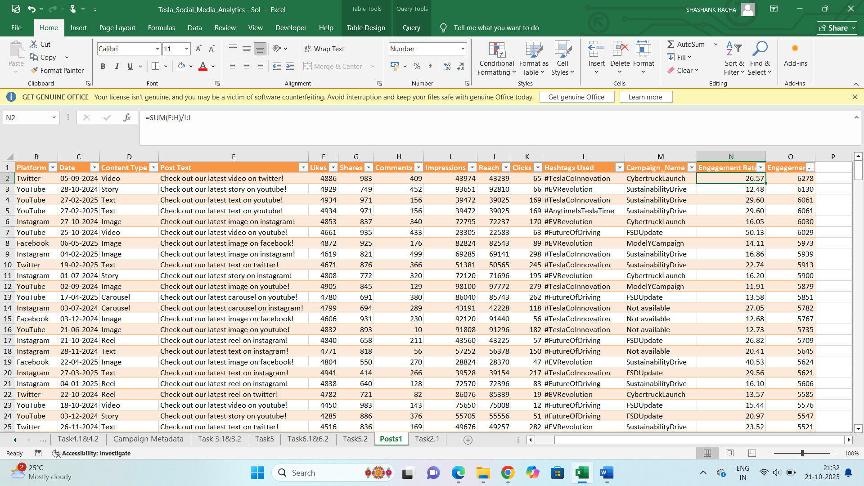

**Task 2: Engagement Analysis**

2.1 Calculate average engagement rate per platform: Engagement Rate = (Likes + Shares + Comments) / Impressions

Load the posts data set into new sheet (post1) after cleaning and removing the duplicates and checking every column is in proper data type. Now create a new column for calculating engagement rate after campaign column which is the last column.

The formula used here is “=sum(likes, shares, comments)/Impressions”

Create a pivot table in new sheet (Task2.1). Drag the platform column under rows and engagement rate under values. Change the value field settings to average. This gives the average of engagement rate for each platform.

**\*Among all the four platforms, Instagram has highest average engagement rate.**

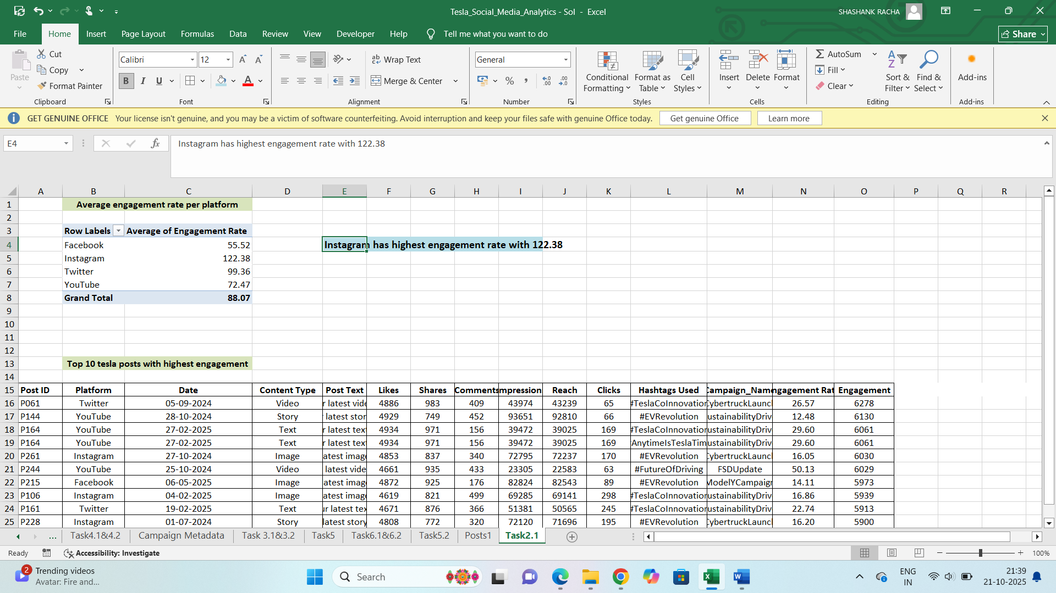

2.2 Identify Top 10 Tesla posts with highest engagement.

Create a new column for calculating engagement. The formula is “=sum (likes, shares, comments)”

Sort the entire data based on engagement column from descending order to ascending order. Now top 10 rows are being the highest engagement, copy top 10 rows to another sheet.

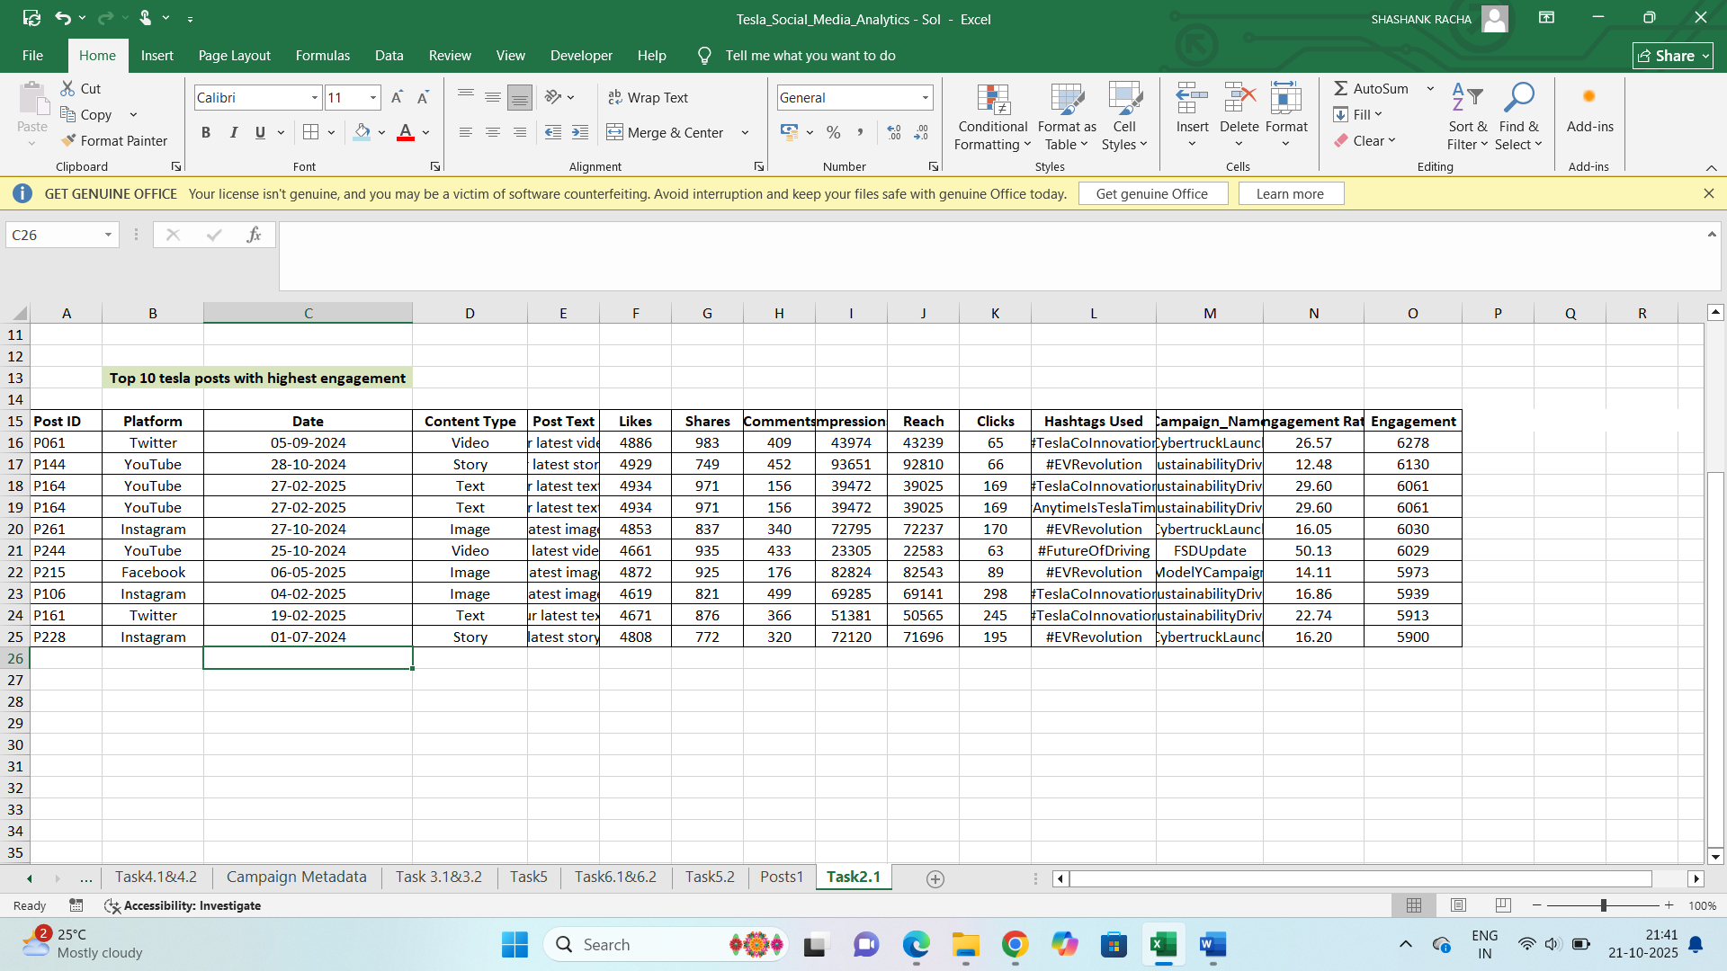

2.3 Create a pivot table showing:

○ Total Likes, Shares, Comments by Content Type & Platform

Create pivot table in task 2.3 sheet using post1 dataset .

Drag the platform and content type columns under rows and likes, shares, comments to values.

Facebook platform gets maximum likes for content type images. Instagram gets maximum shares for stories content.

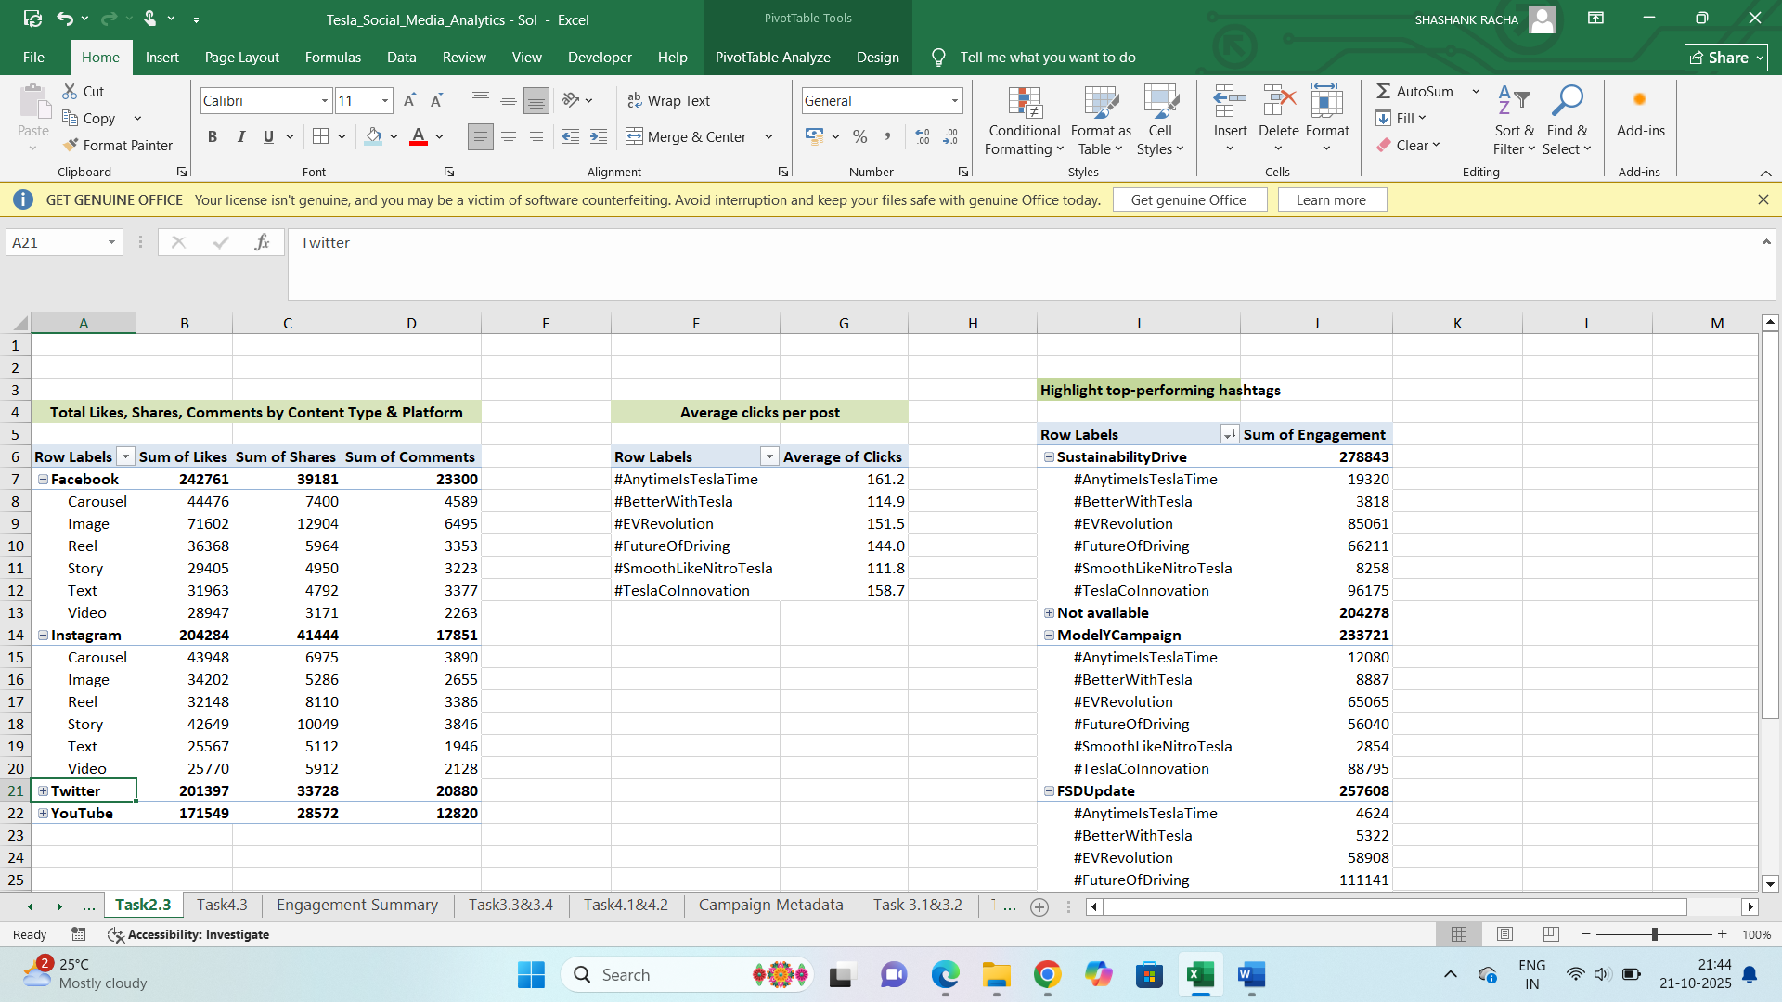

○ Average Clicks per post by Hashtag

Create a pivot table using post1 data set.

Drag the hashtags column under rows section and clicks under values section.

Change the value field settings to average.

**#AnytimeIsTeslaTime hashtag got highest average clicks.**

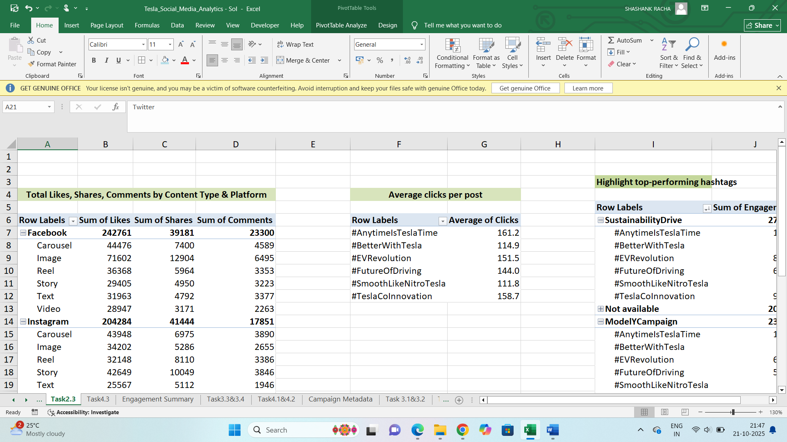

2.4 Highlight top-performing hashtags (#Cybertruck, #ModelY, #EVAdoption, etc.).

Create a pivot table using post1 data set.

Bring the campaign name and hashtags column to rows and engagement column to values. This shows the sum of engagement for each hashtag for every campaign

**#TeslaCoInnovation, #FutureOfDriving are the most popular hashtags for all campaigns.**

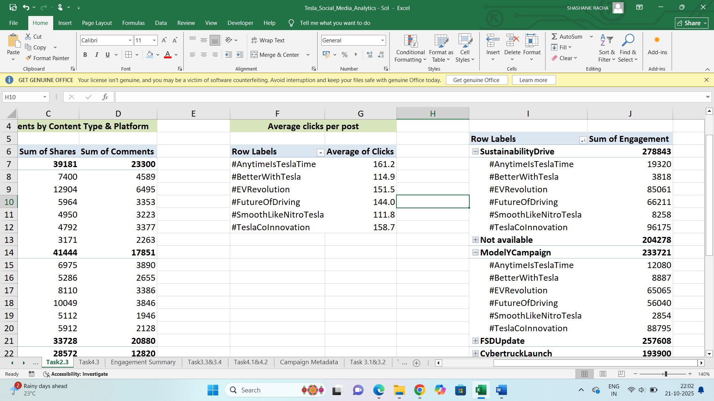

**Task 3: Platform Analysis**

3.1 Identify the platform with highest engagement

Create a pivot table using post1 data.

Bring platform and content type columns to rows and engagement column to values.

**You tube for stories and videos content has highest engagement among four platforms.**

**Facebook for Carousels and reels also has good engagement.**

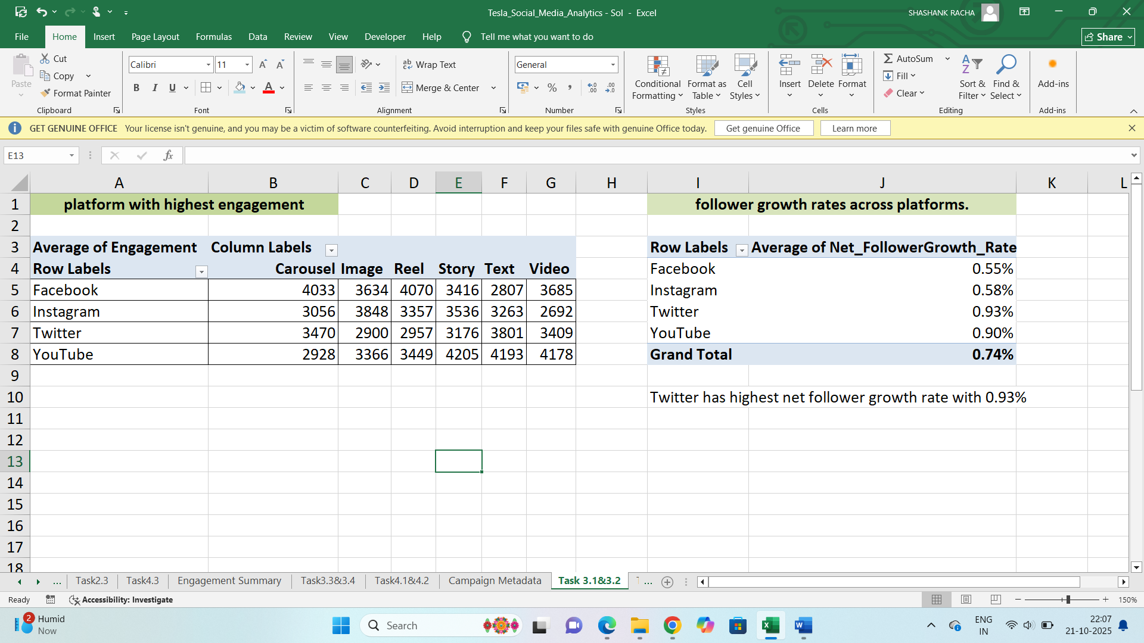

3.2 Compare follower growth rates across platforms.

Calculate net follower growth rate using the formula “new followers-unfollows/Total followers”.

Create a pivot table using engagement summary data set. Bring platforms to rows section and net follower growth rate to values. Change value field settings to average.

Twitter has highest net follower growth rate with 0.93%



3.3 Visualize Engagement vs. Ad Spend per platform.

Create two pivot tables, one for getting engagement for each platform by using post1 data and another for ad spend for each platform from engagement summary data set.

Combine the two tables for engagement and ad spend.

Insert the scatter graph for this data to find the relationship between engagement and ad spend.

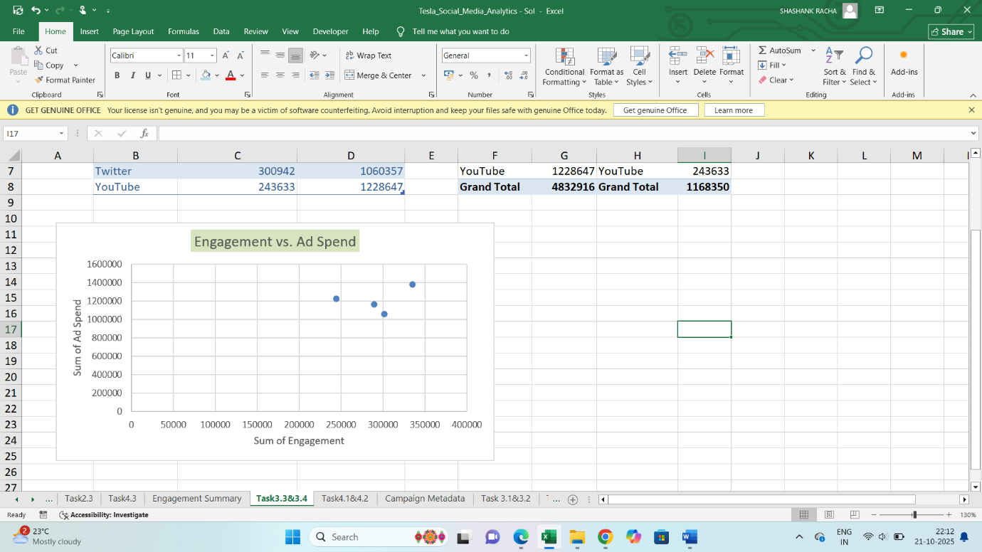

3.4 Advise: Should Tesla focus on Twitter + YouTube (product announcements + demos) or maintain a multi-platform strategy?

Facebook platform gets maximum likes for content type images. Instagram gets maximum shares for stories content. Each platform is performing the best in specific content types. So it is better to focus on multi-platform strategy to attract the customers and builds a powerful ecosystem.

**Task 4: Hashtag & Content Strategy**

4.1 Identify most frequently used Tesla hashtags.

Create a pivot table using posts1 data.

Bring the hashtags column to rows and values section. This gives how many times hashtag is used.

**#TeslaCoInnovation is the most frequently used hashtags.**

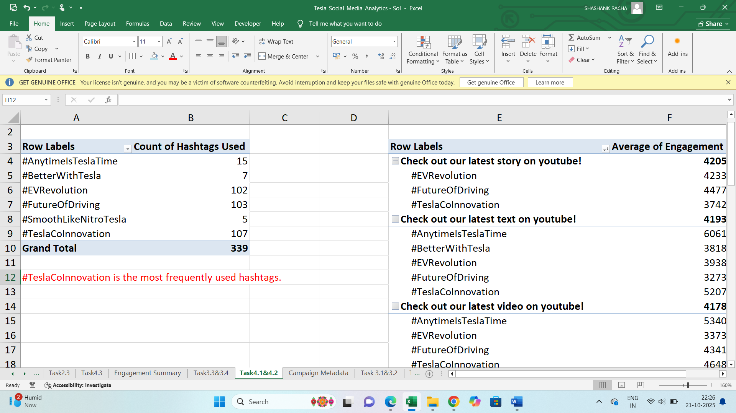

**4.2 Compare average performance of posts containing each hashtag.**

Create a pivot table using posts1 data.

Bring the post text and hashtags column to rows and engagement column to values section.

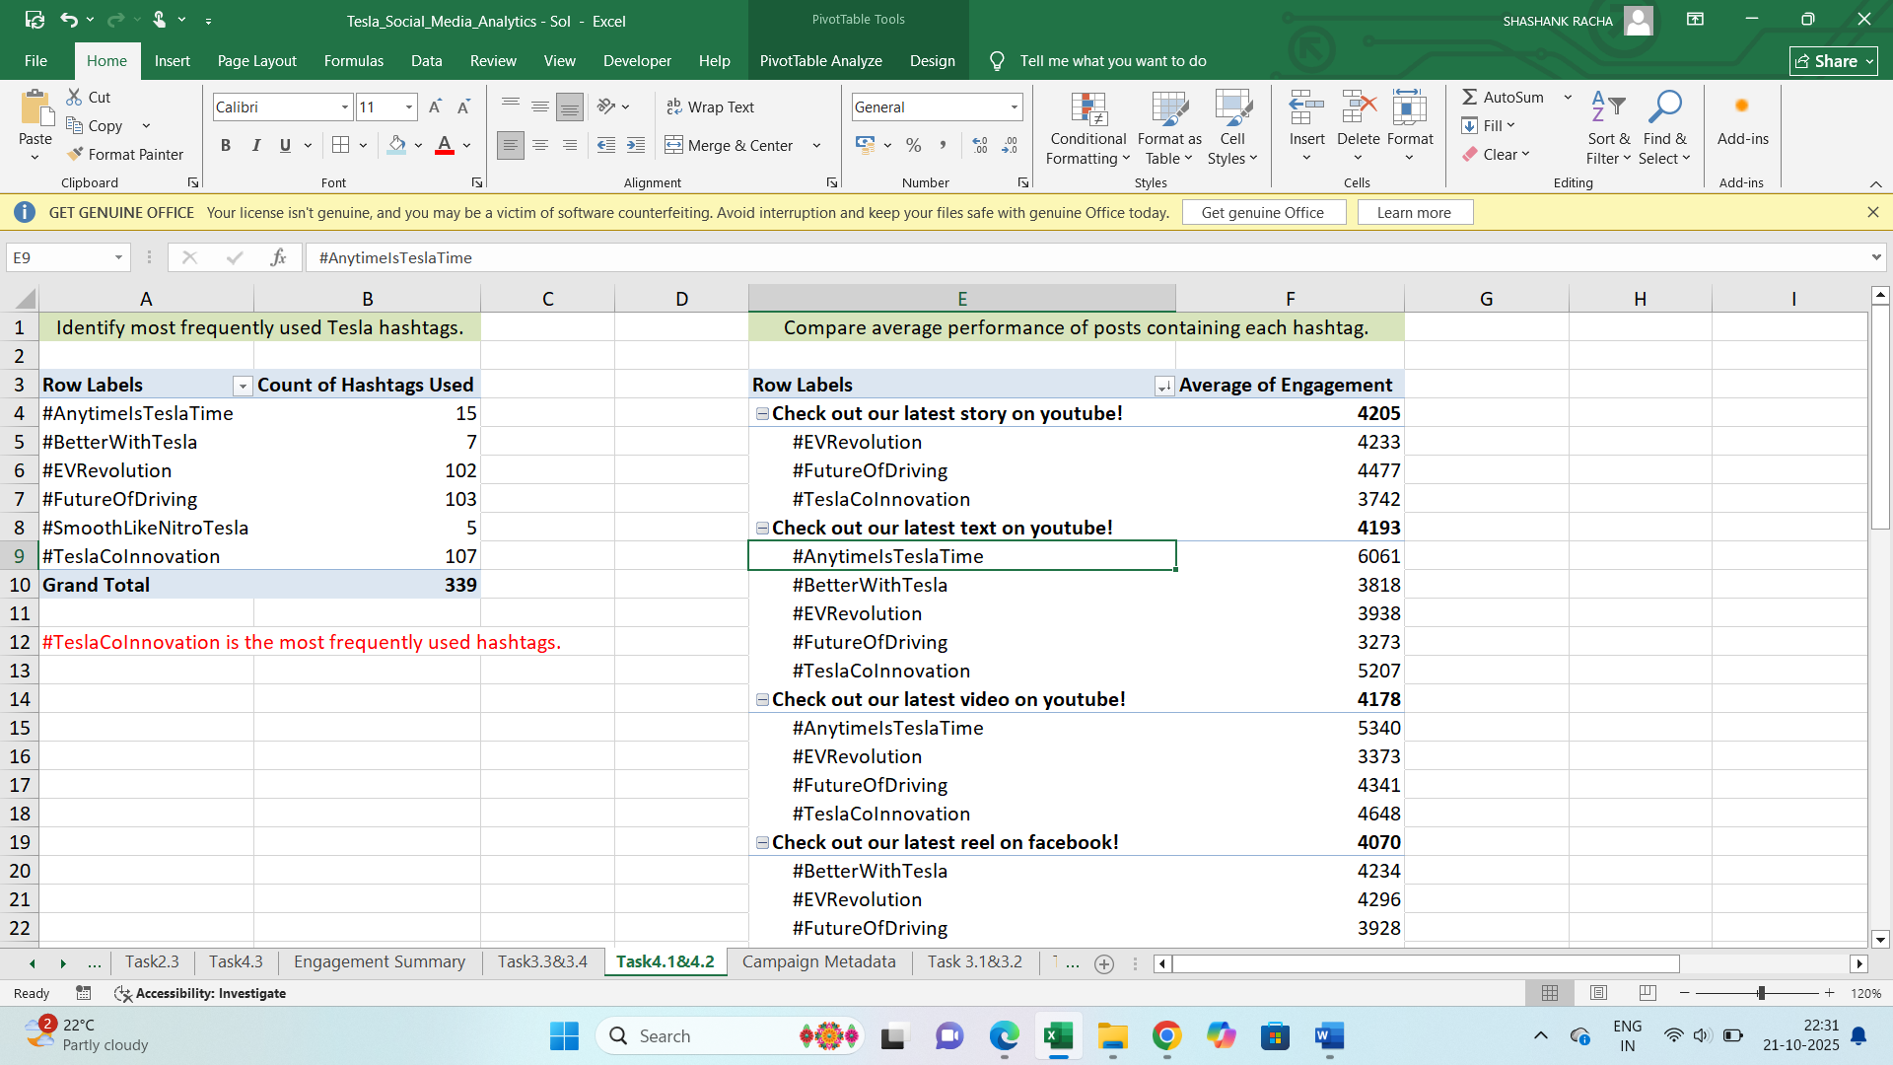

**4.3 Compare content performance: ○ Videos (product demos, Elon talks) ○ Images (car designs, interiors) ○ Carousels (features, comparisons)**

Create a pivot table using posts1 data.

Bring the platform and content type columns to rows and likes, shares, comments to values. Change the field settings to average. This shows the averages of likes, shares, comments for each platform in its content type.

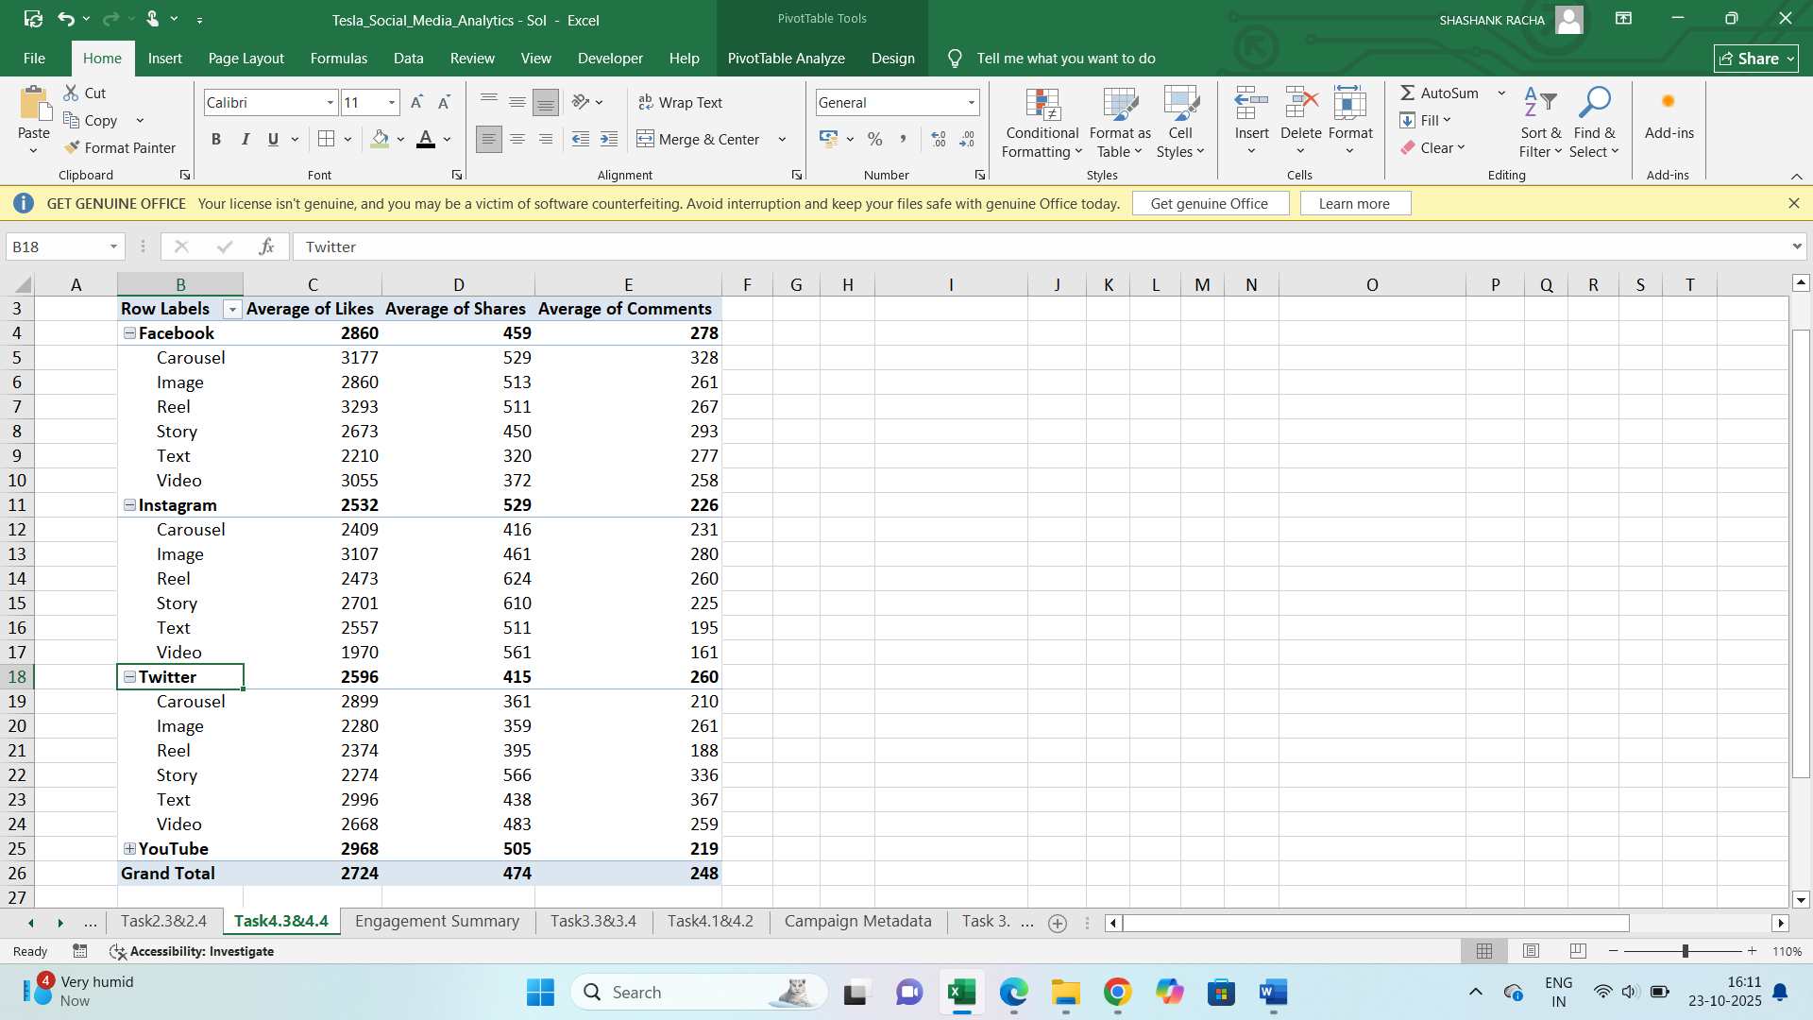

4.4 Recommend content type priorities per platform (e.g., videos on YouTube, car images on Instagram).

After observing the number of likes, shares, comments for each platform in all content types, I would recommend the following content types in each platform.

* Facebook : carousels
* Instagram : Images and reels
* Twitter: Texts
* YouTube : Stories and videos

**Task 5: Campaign Effectiveness**

5.1.1 Total & Average Impressions, Likes, Clicks per Campaign.

Create a pivot table using posts1 data.

Bring the campaign name column to rows and Impressions, likes, clicks to values section. This gives the sum. Bring again these columns to values section and change the field settings to average.

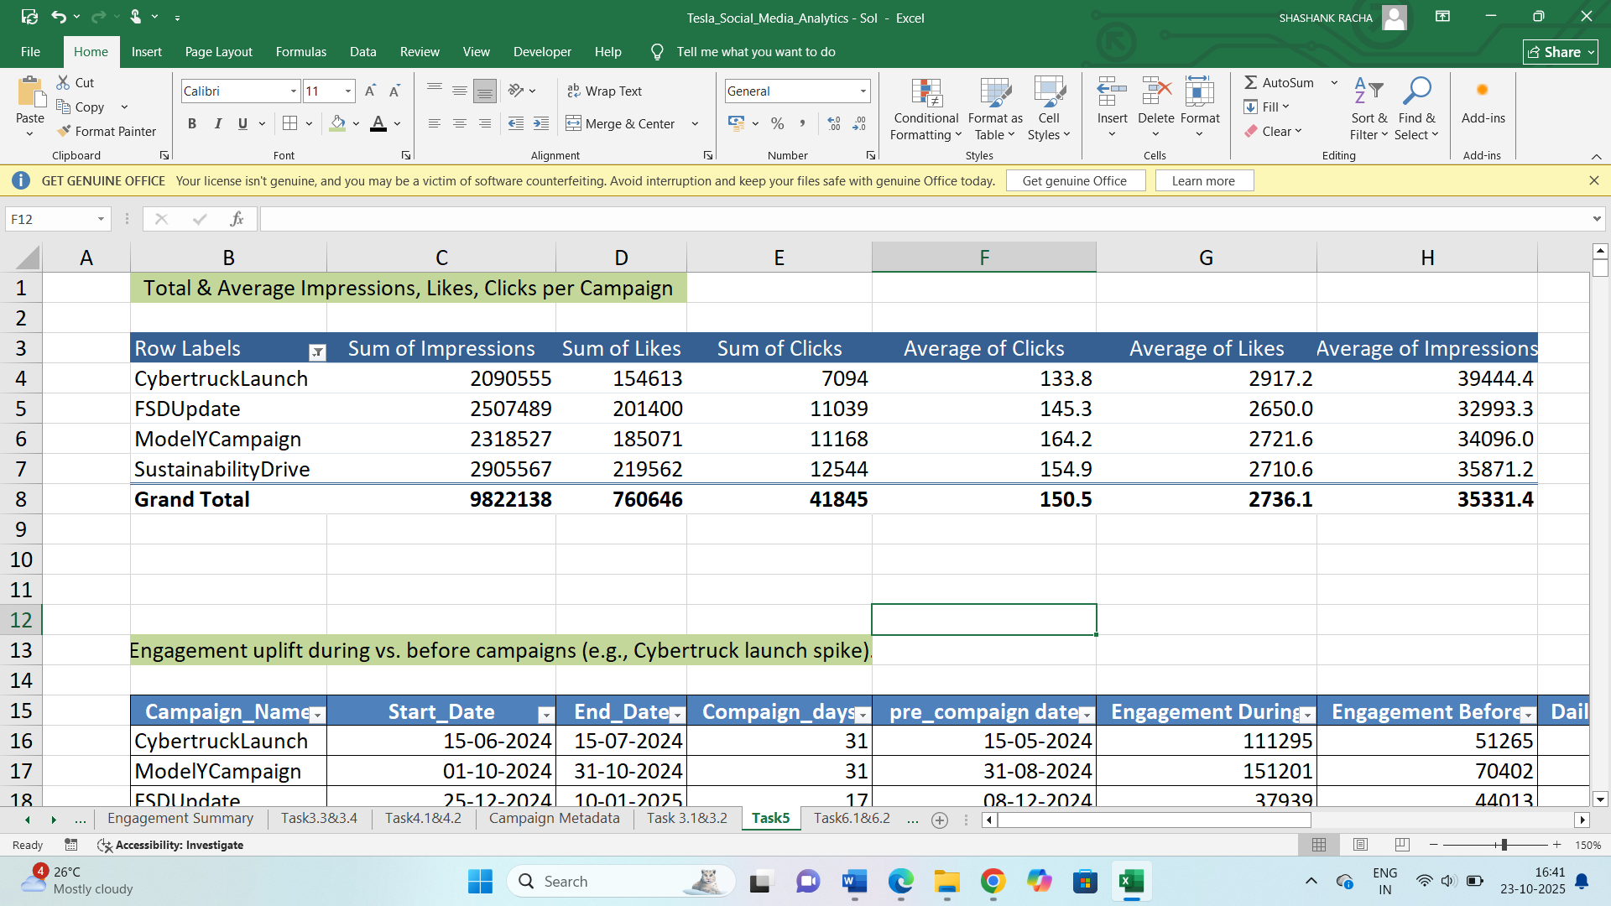

5.1.2 Engagement uplift during vs. before campaigns (e.g., Cybertruck launch spike).

Create a manual table by taking the first three columns from Campaign Metadata i.e., campaign name, start date, end date.

Calculate the days between start date and end date as campaign days. (End date-start date)+1

Calculate pre campaign date by subtracting campaign days from start date. Start date-campaign days

Engagement during: Total sum of likes, shares, comments in between the start date and end date from posts1 data

SUM(SUMIFS(Posts_2[Likes],Posts_2[Date],">="&C16,Posts_2[Date],"<="&D16),SUMIFS(Posts_2[Shares],Posts_2[Date],">="&C16,Posts_2[Date],"<="&D16),SUMIFS(Posts_2[Comments],Posts_2[Date],">="&C16,Posts_2[Date],"<="&D16))

Engagement before: Total sum of likes, shares, comments in between pre campaign date and start date from posts1 data

SUM(SUMIFS(Posts_2[Likes],Posts_2[Date],">="&F16,Posts_2[Date],"<="&C16),SUMIFS(Posts_2[Shares],Posts_2[Date],">="&F16,Posts_2[Date],"<="&C16),SUMIFS(Posts_2[Comments],Posts_2[Date],">="&F16,Posts_2[Date],"<="&C16))

Daily engagement during : Divide the engagement during by campaign days.

Daily engagement before : divide the engagement before by campaign days.

Engagement uplift: (Daily Engagement during-Daily Engagement before)/Daily Engagement during

**CybertruckLaunch campaign has highest engagement uplift with 53.94%**

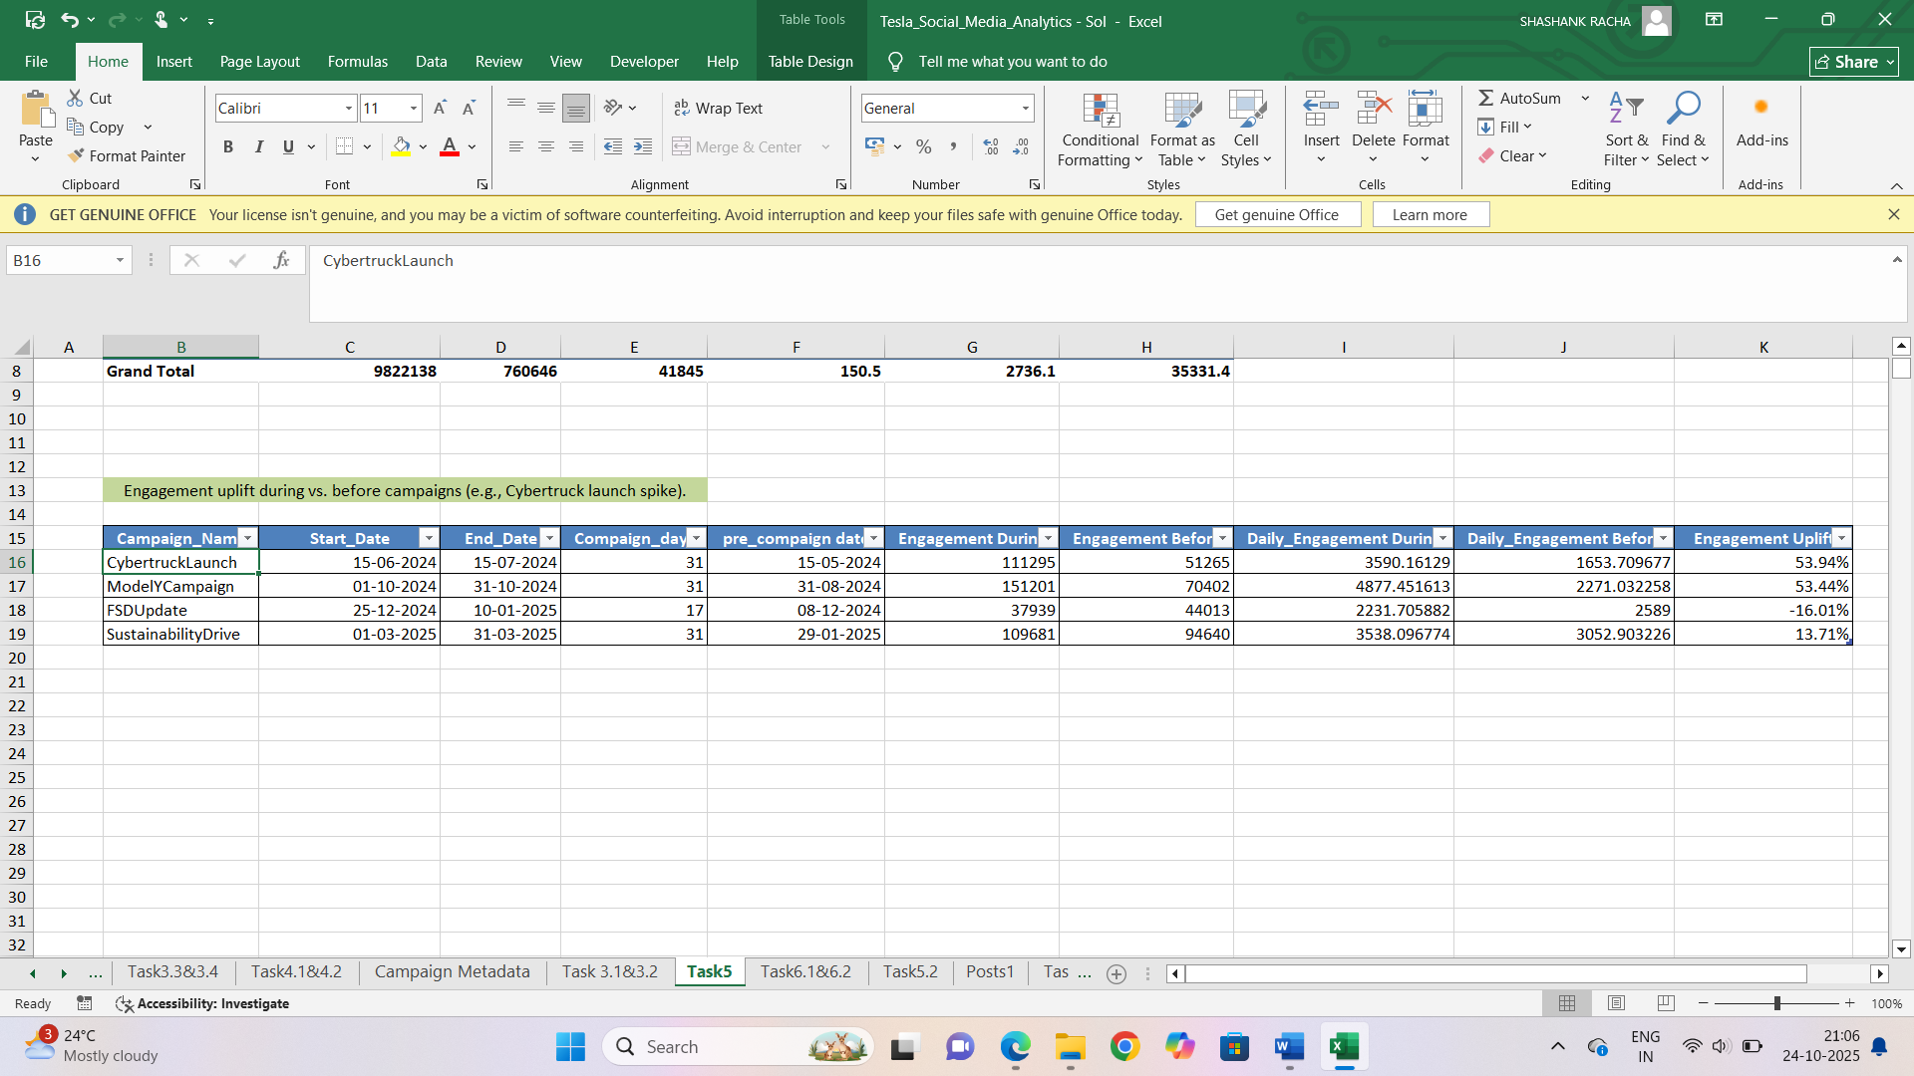

5.2 Which campaign had the highest ROI (engagement vs. spend)?

Create a manual table from campaign metadata by taking campaign name and total budget columns.

Create a pivot table for calculating the total engagement for each campaign from posts1 data.

Now we have total budget and total engagement for each campaign. Calculate engagement per rupee by dividing total engagement by total budget.

SustainabilityDrive campaign has high engagement per rupee with 1.549 means it has highest Return On Investment.

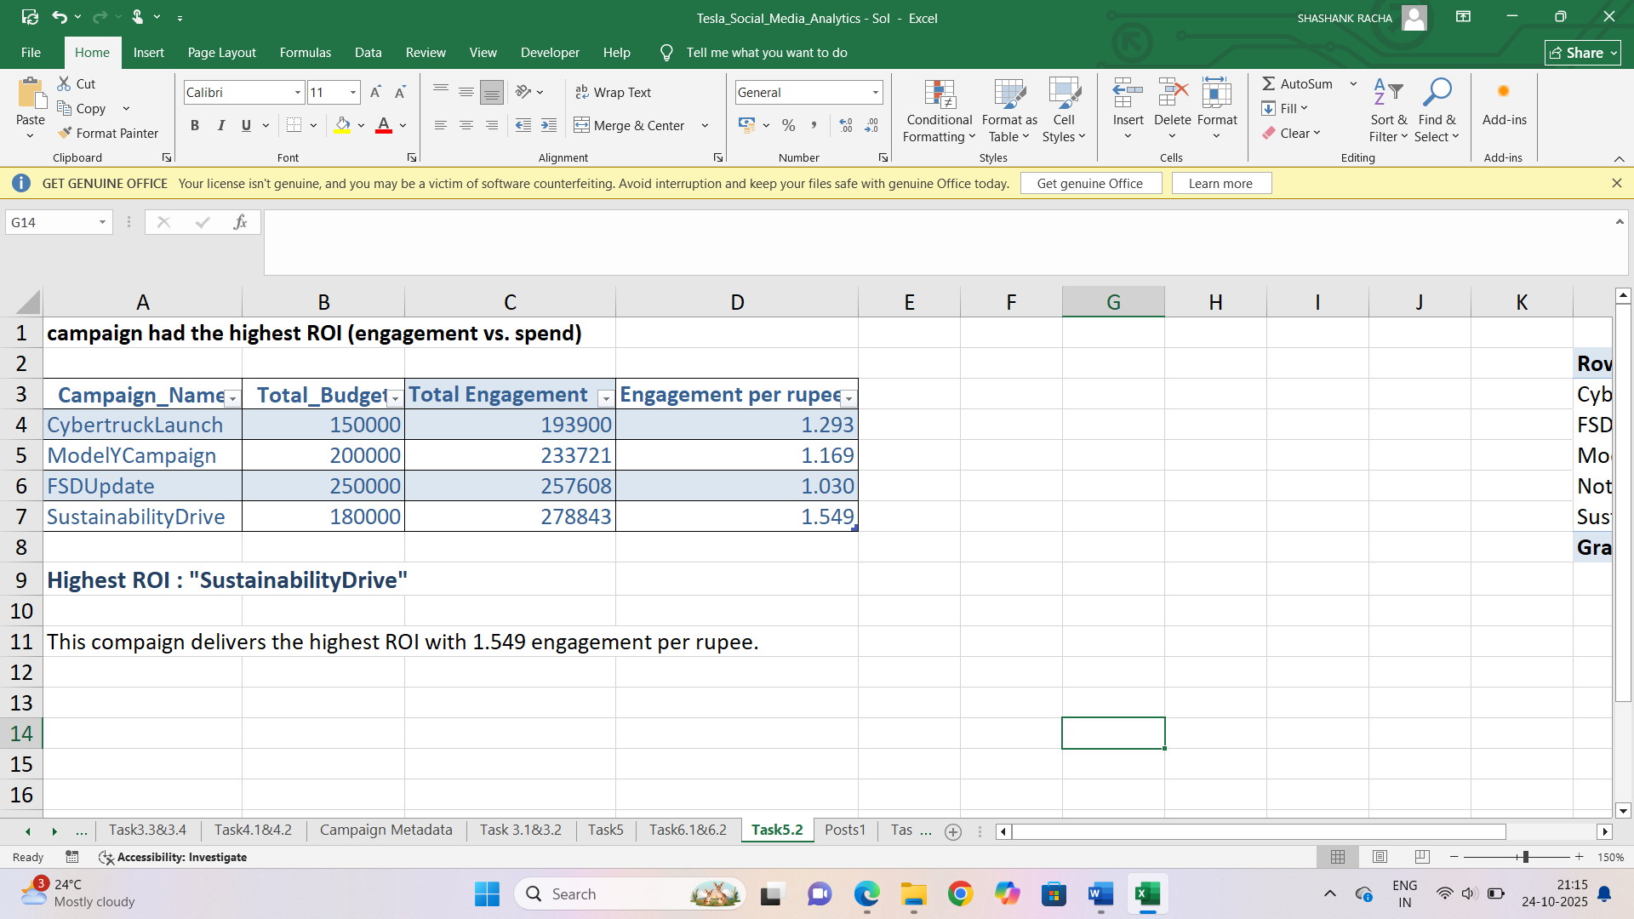

5.2.2 Which campaign drove the strongest follower growth?

Create a manual table with campaign name, Start date, end date and follower gain.

Write a formula to sum the follower gains in the period between start date and end date from engagement summary data.

=SUMIFS(Engagement_Summary[Follower_Gain], Engagement_Summary [Week_Start_Date],">="&Task5.2!I4, Engagement_Summary [Week_Start_Date],"<="&Task5.2!J4)

SustainabilityDrive campaign drove the strongest follower growth with 16078 followers gain

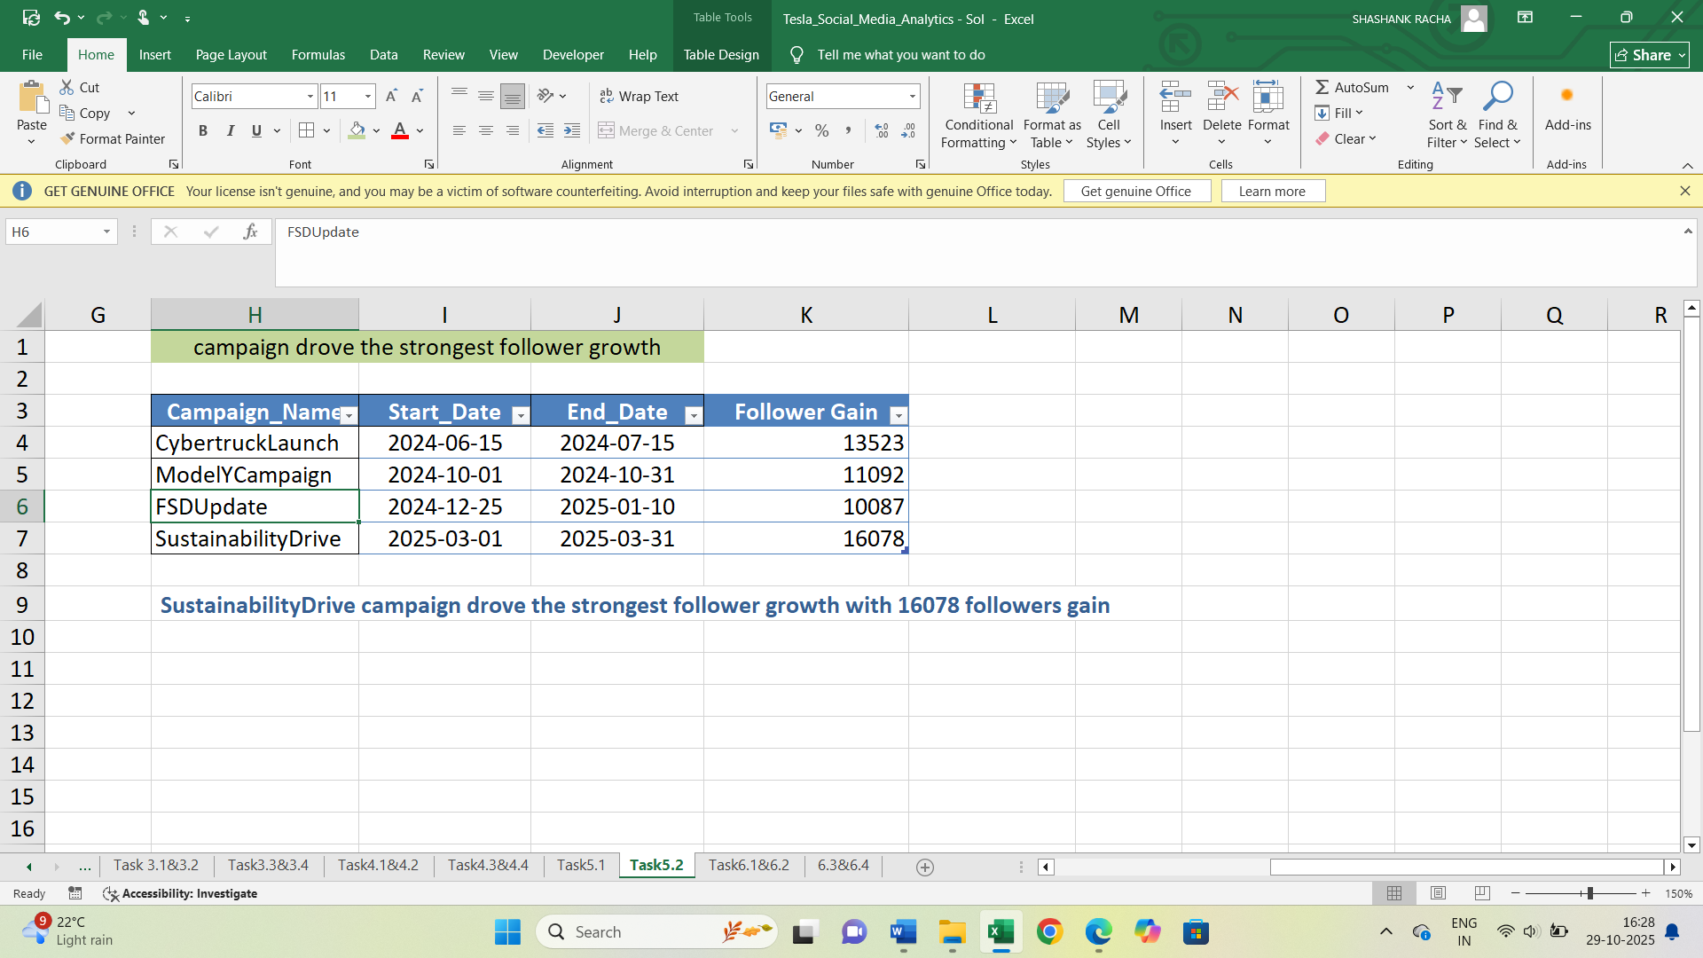

**Task 6: Follower Retention & Loyalty**

6.1 Visualize weekly follower growth per platform (line chart).

In engagement summary table create a new column for follower gain=new followers-unfollows

Create a pivot table from engagement summary table. Bring week_start_date column to rows section and follower gain to values, platform column to columns section.

This gives the sum of followers gain for each platform in every week.

Insert a line chart for this data from charts ribbon.

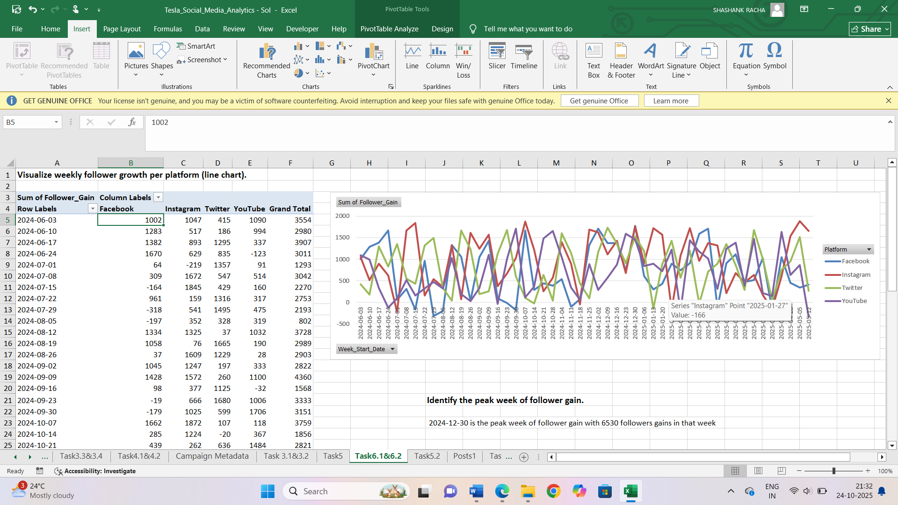

6.2 Identify the peak week of follower gain.

Create a manual table by taking week start date and follower gain.

Sort the table in descending order (from highest to lowest).

2024-12-30 is the week having highest followers gain with value 6530.

FSDUpdate campaign was running in that time period.

So this campaign also attracts the followers with high efficiency.

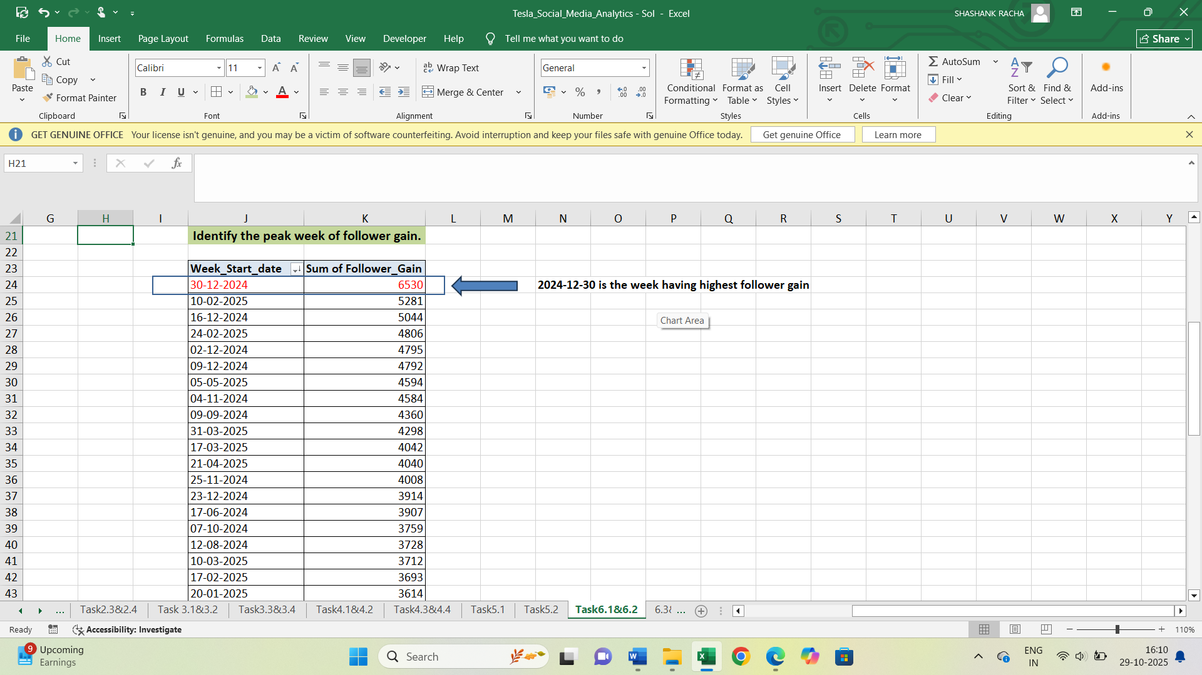

6.3 Use moving averages to smooth growth trends.

By taking week start date and follower gain create a line chart.

After right click on the graph we can see the trendline option. In the trendline option click select moving averages option and period as 6.

This shows a line on the chart that smoothers the peaks and shows the average line chart

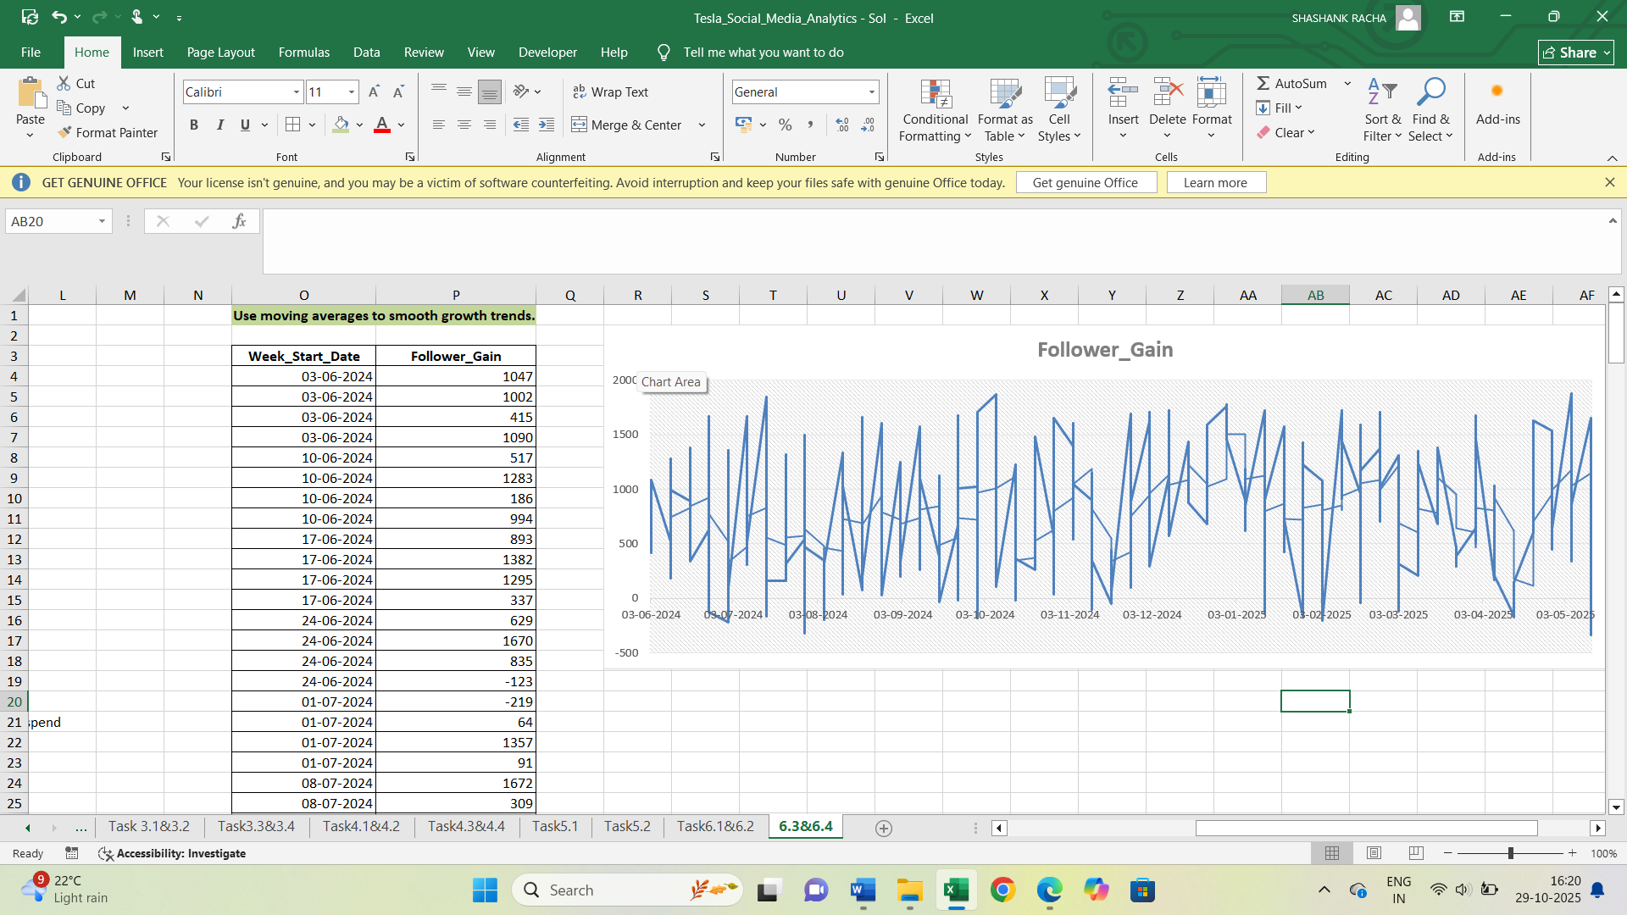

6.4 Correlate ad spend vs. follower growth using scatter plots.

By taking ad spend and follower growth create a scatter chart. We can find Correlation value between ad spend and follower growth by correl function. We got 0.0859 correlation value. Since it is close to zero there is weak relationship between ad spend and follower growth. 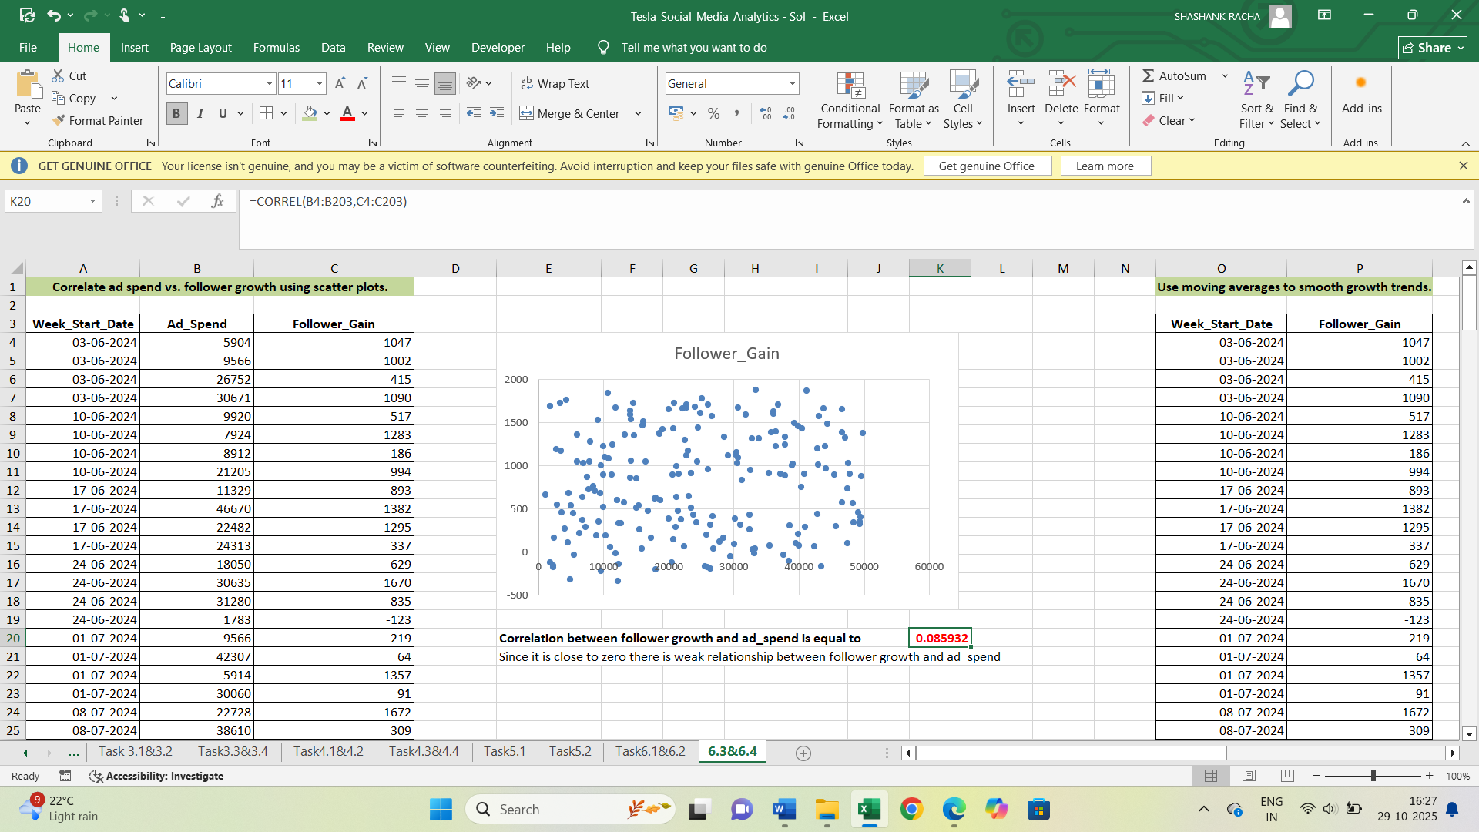

**Insights & Recommendations:**

* Focus more on community growth related content which eventually draws the attention of people and helps to improve the followers.
* There should be proper calculation of investments across the platforms for ad spend because there is no direct relationship for ROI and engagement. Avoid spending to only one platform as this results in loyalty degradation.
* Product launches and campaigns influence follower growth by increasing brand awareness and visibility. It also builds trust among audience with strategic content.
* Through consistent communication, taking valuable feedbacks and acting on it creates loyalty and making followers feel valued.

|  |
| --- |
|  |